Disaster Prediction

In this project we have utilized Flood Prediction dataset to predict future flood in different cities as this only dataset available related to future places disaster detection. To predict future disaster place we have trained Random Forest algorithm on above dataset as this algorithm giving an accuracy of more than 97%. This algorithm will take current year, month and weather information as input from various places and then by analyzing input data will predict flood in different places.

By utilizing above prediction, disaster team can arrange required facilities to handle situation and to evacuate peoples. Disaster team can utilize this application to spread guidelines and can send and receive messages as two way communication for urgent needs.

To train above algorithm we are using below dataset

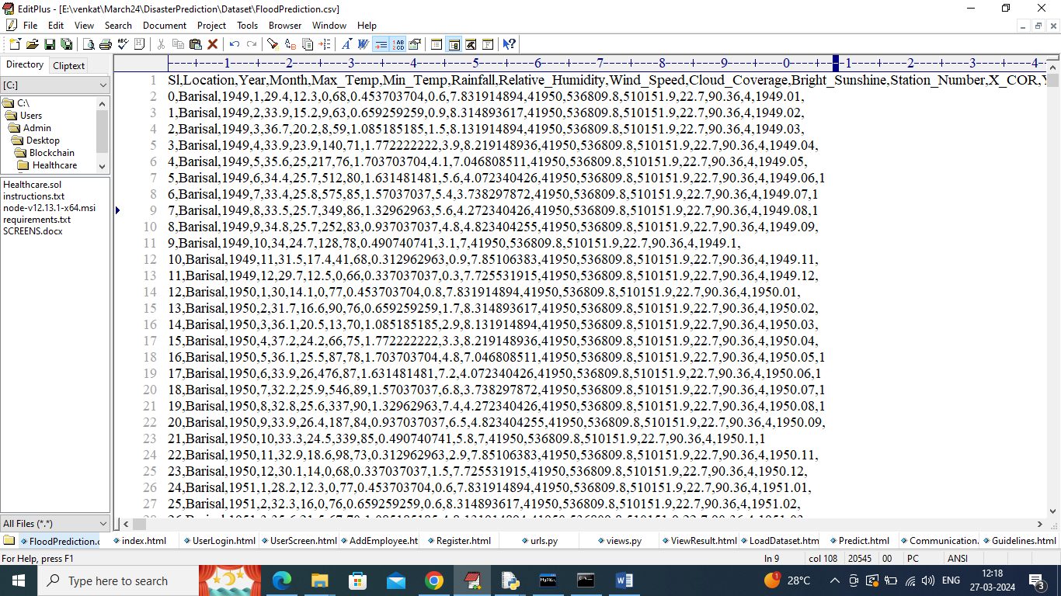

In above dataset we have location and weather information and by using above dataset will train Random forest algorithm.

Input data to Random Forest can be feed from weather sensors but we don’t have weather sensor so we are uploading weather information from test data file. This test data can be sent to python DJANGO Restful API which can read data and then apply Random Forest algorithm to predict flood disaster in different places.

To implement this project we have designed following modules

1. Register: disaster team or normal user can sign up with the application
2. User Login: can login to application
3. Load & Process Dataset: using this module we can load past weather information dataset and then clean and process dataset
4. Train ML Algorithm: clean and process dataset will be split into train and test where application will be using 80% data for training and 20% for testing. 80% training data will be input to Random Forest algorithm to train a model and this model will be applied on 20% test data to calculate prediction accuracy
5. Guidelines: application will display guidelines to follow upon disaster occur
6. Predict Next Possible Disaster: will upload test data and then application will send all test data to DANGO REST API which will read all test data and then apply Random Forest algorithm to predict all places where possible disaster will occur and send response back to application
7. Communications: using this module user can post queries which will read and reply by other persons
8. View Communications: all posted replies can be read by using this module

SCREEN SHOTS

To run project install python 3.7 and then install all packages given in requirements.txt file and then copy content from database.txt file and paste in MYSQL to create database.

Double click on ‘run.bat’ file to start python server and get below page

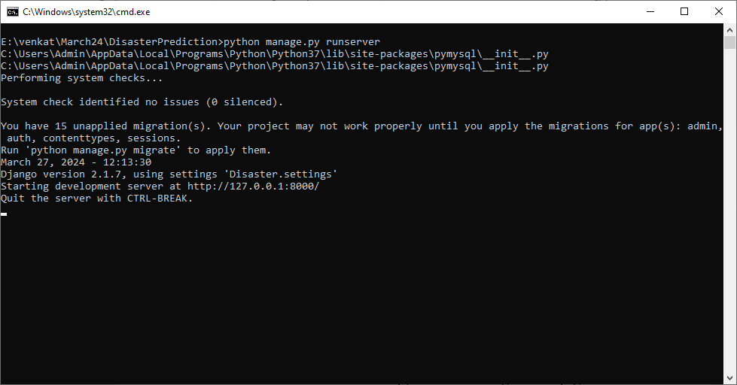

In above screen python server started and now open browser and enter URL as <http://127.0.0.1:8000/index.html> and press enter key to get below page

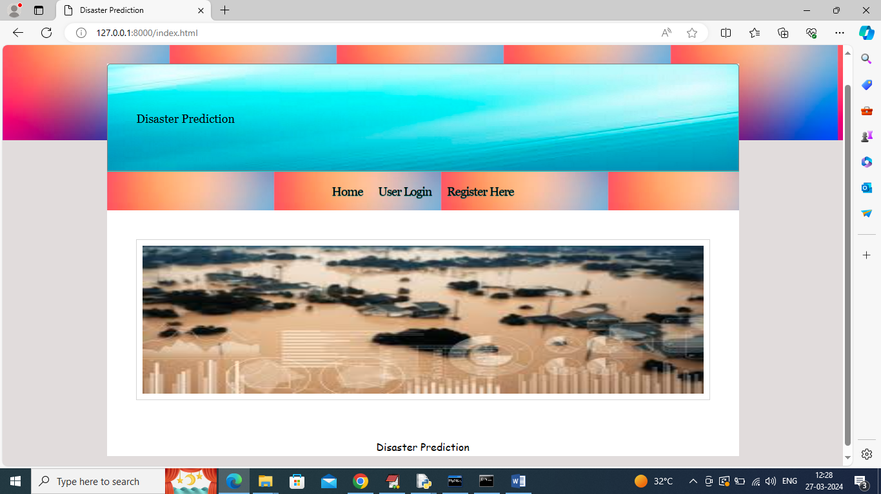

In above screen click on “Register Here’ link to get below page

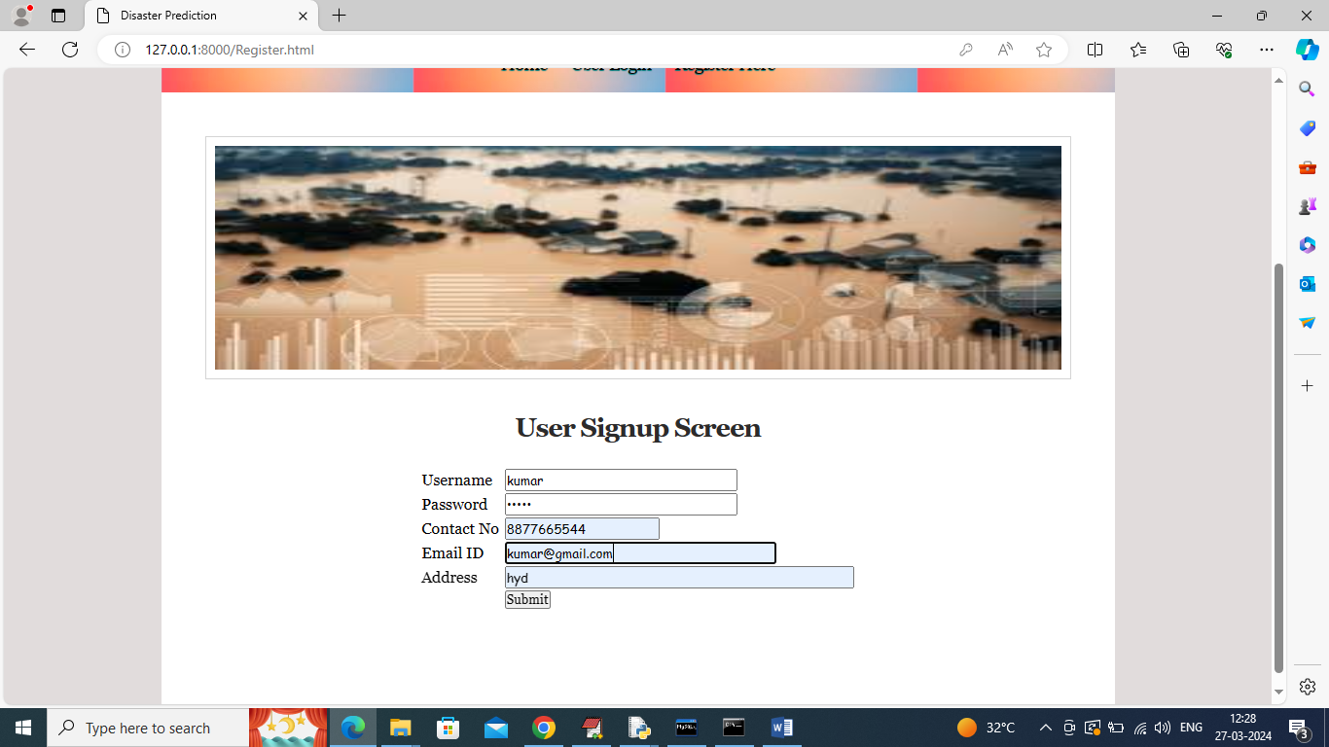

In above screen user is entering sign up details and then press button to get below page

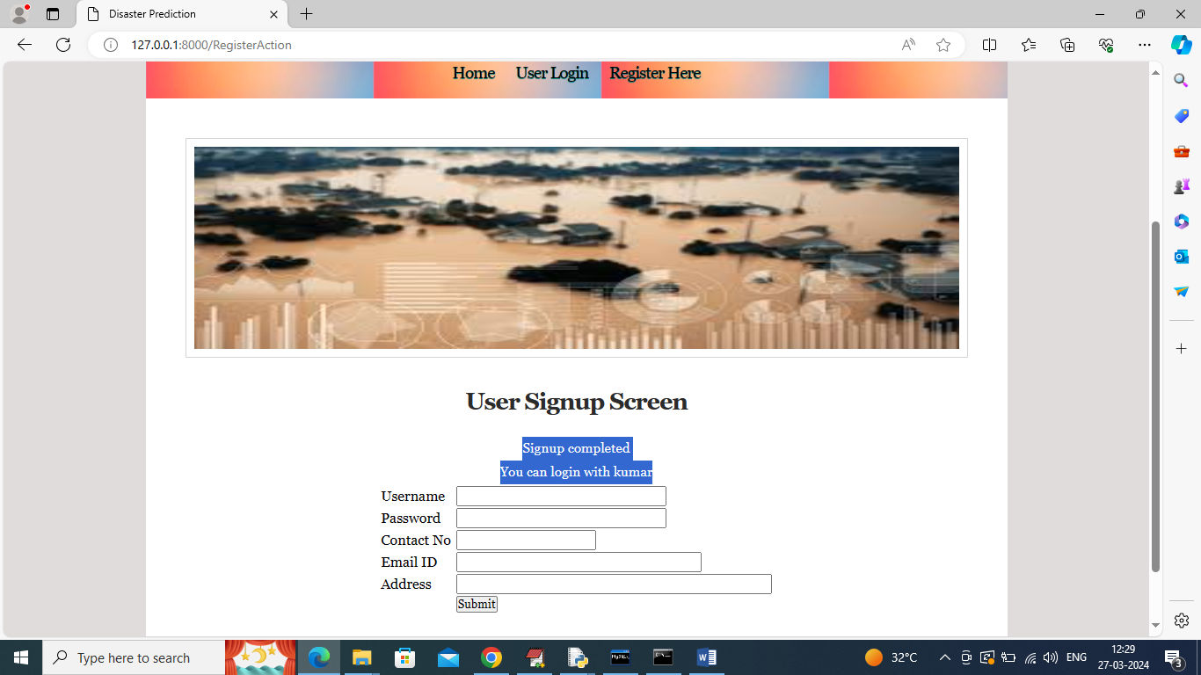

In above screen user sign up completed and now click on ‘User Login’ link to get below page

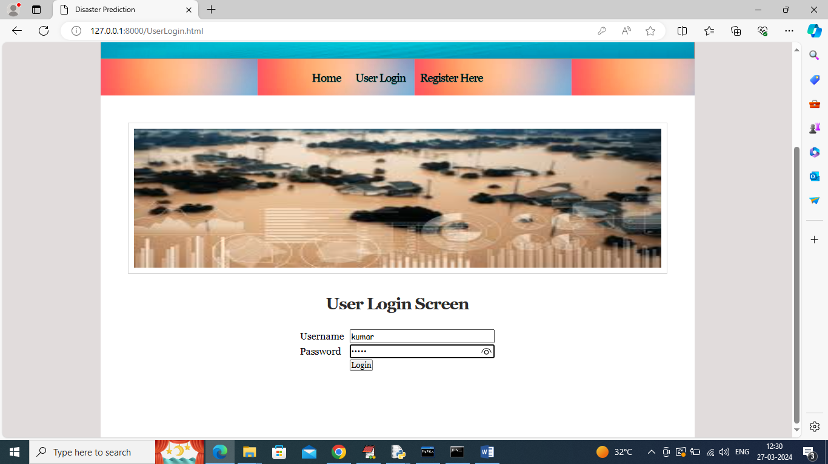

In above screen user is login and after login will get below page

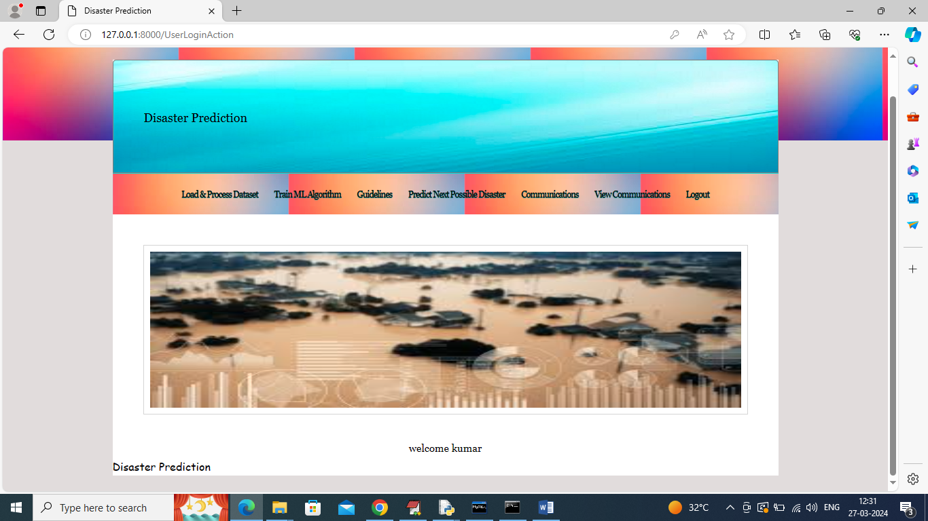

In above screen click on ‘Load & Process Dataset’ link to get below page

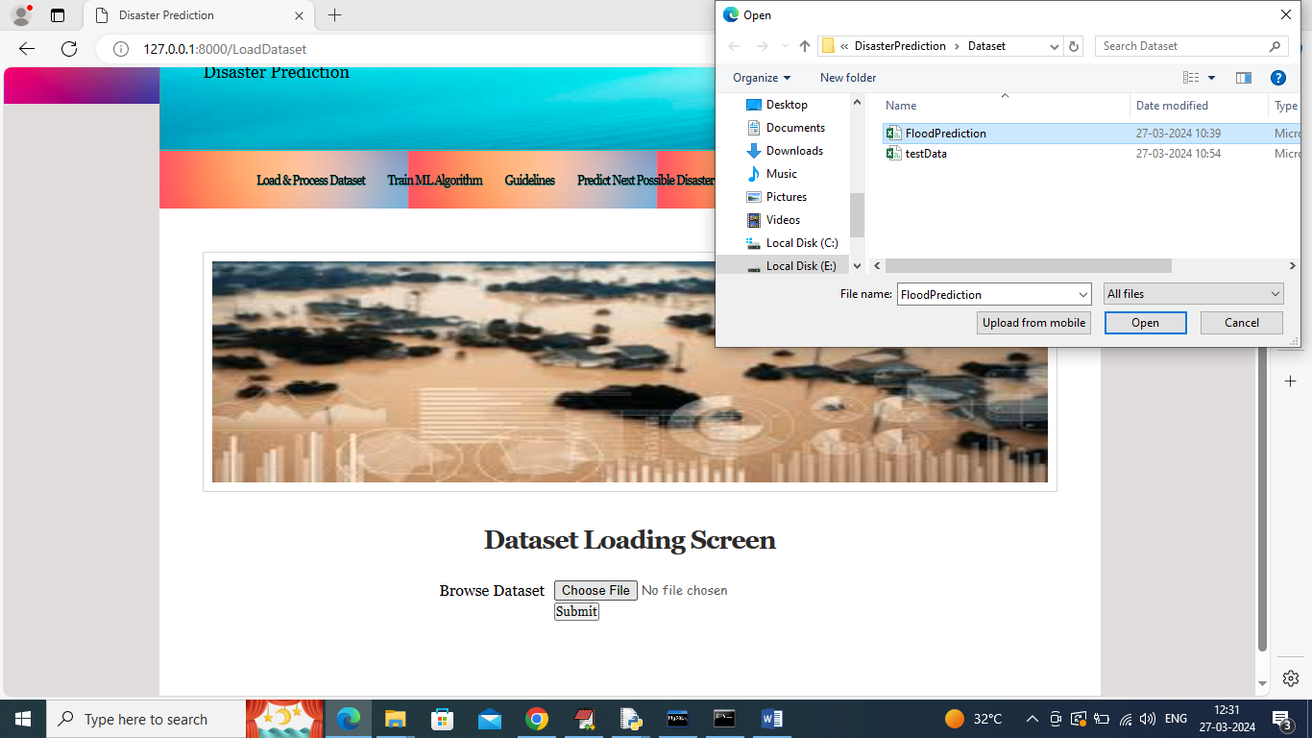

In above screen selecting and uploading ‘Flood’ dataset and then click on ‘Open’ and ‘Submit’ button to load dataset and get below page

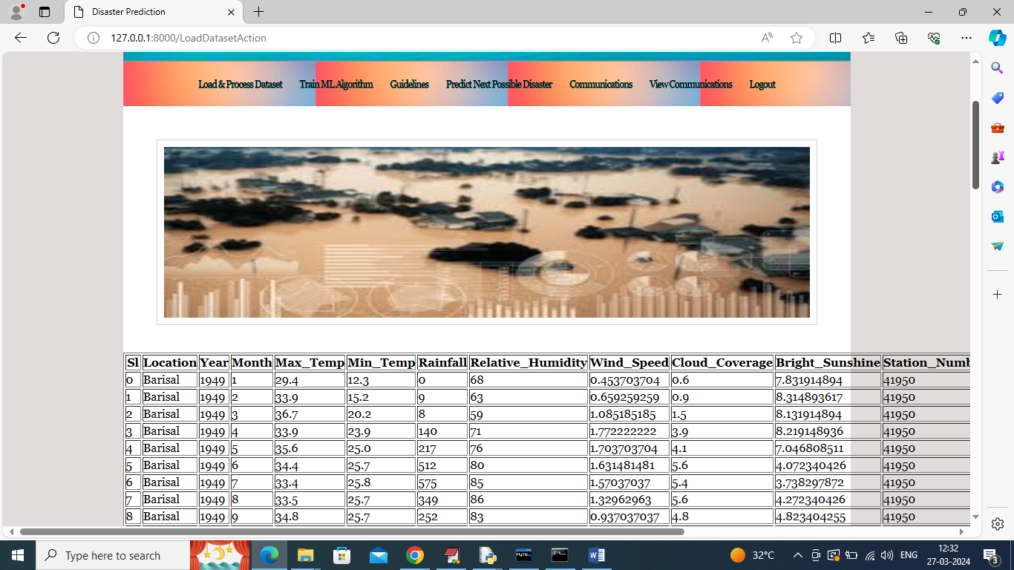

In above screen dataset loaded and now click on ‘Train ML Algorithm’ link to train algorithm and get below page

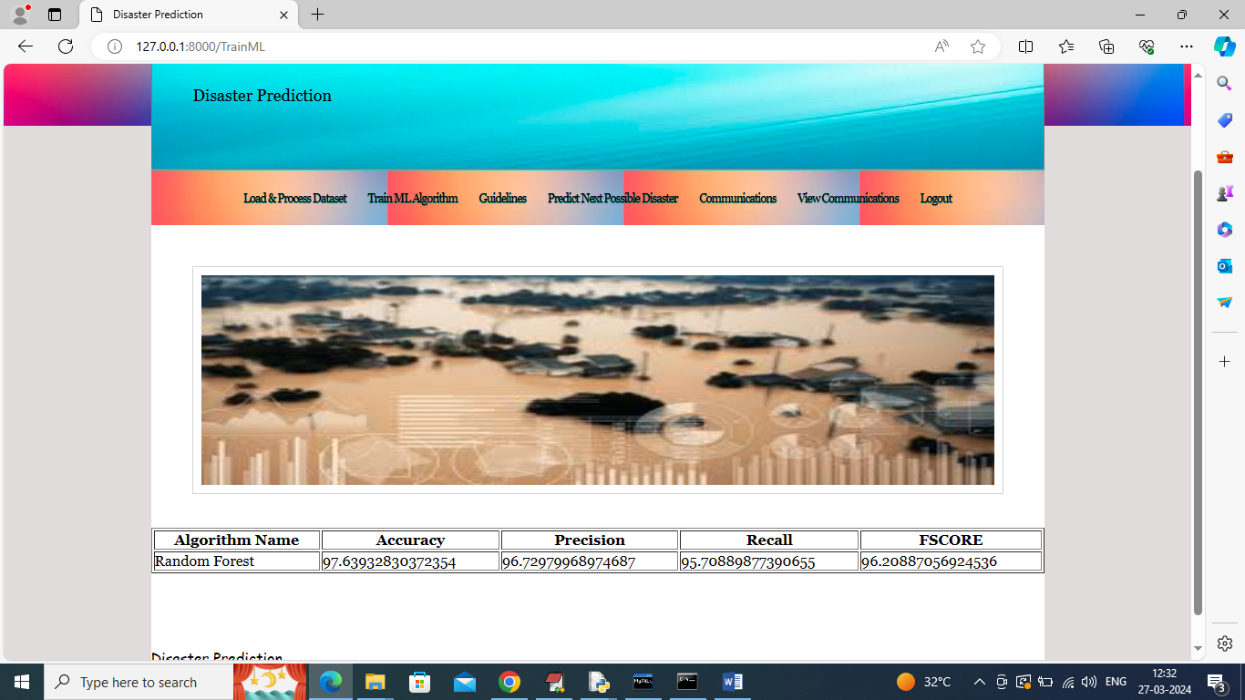

In above screen Random Forest training completed and algorithm got 97% accuracy and can see other metrics like precision, recall and FSCORE and now click on ‘Guidelines’ link to view guideline to follow

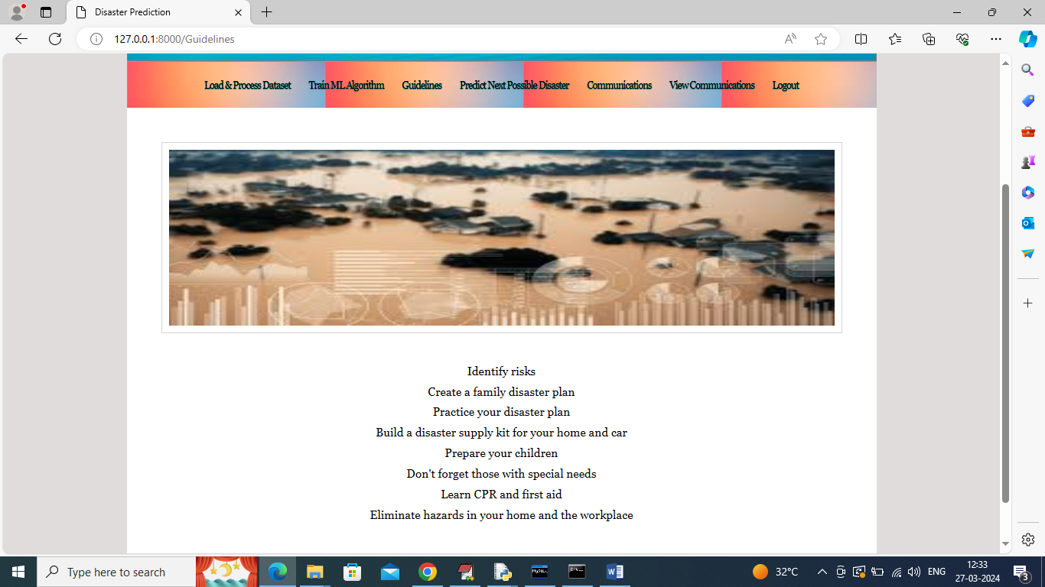

In above screen can see few guideline to follow and now click on ‘Predict Next Possible Disaster Place’ link to get below page

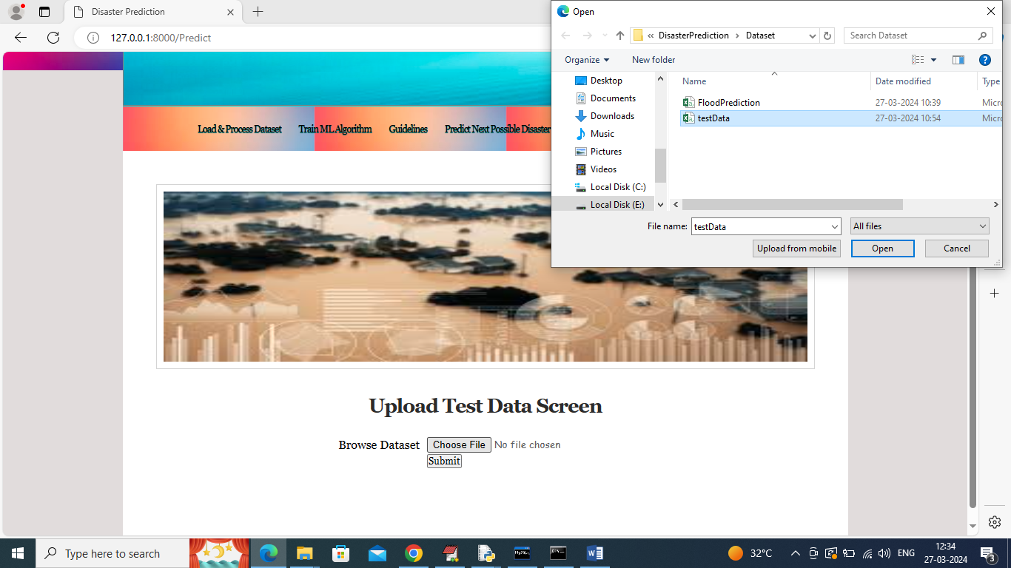

In above screen selecting and uploading test data file and then click on ‘Open’ and ‘Submit’ button to get below prediction

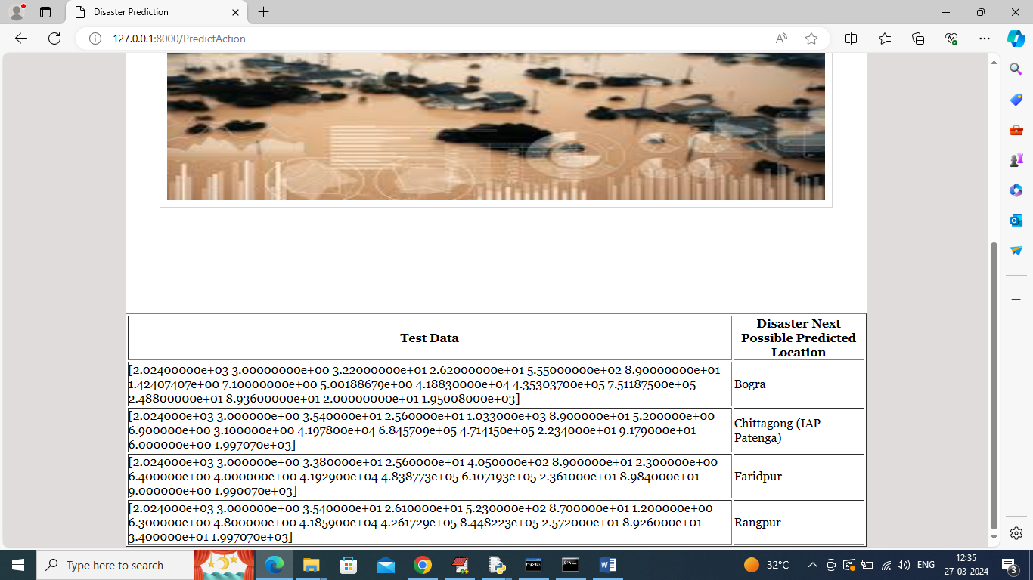

In above screen in first column can see Weather Test Data Values and in second column can see name of places where disaster may occur and now click on ‘Communication’ link to post query to others

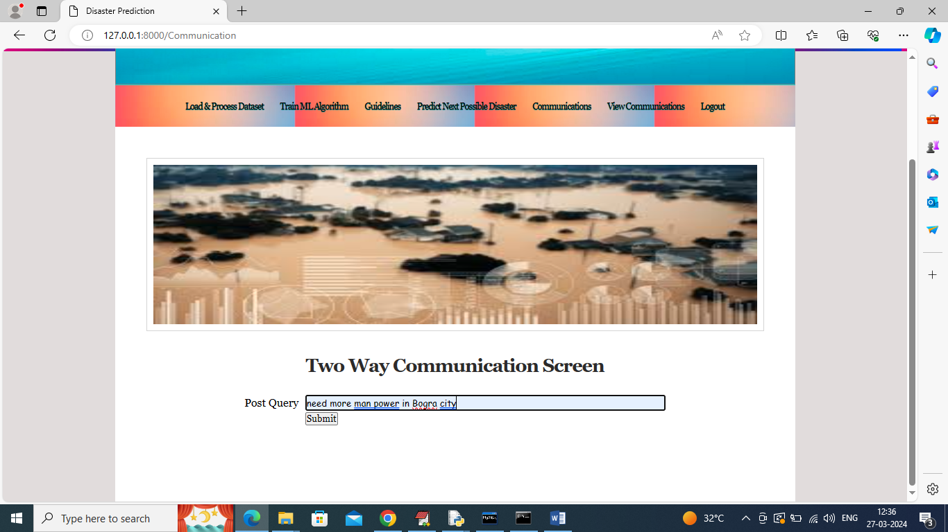

In above screen posting some query as communication and other user will reply as two way communication

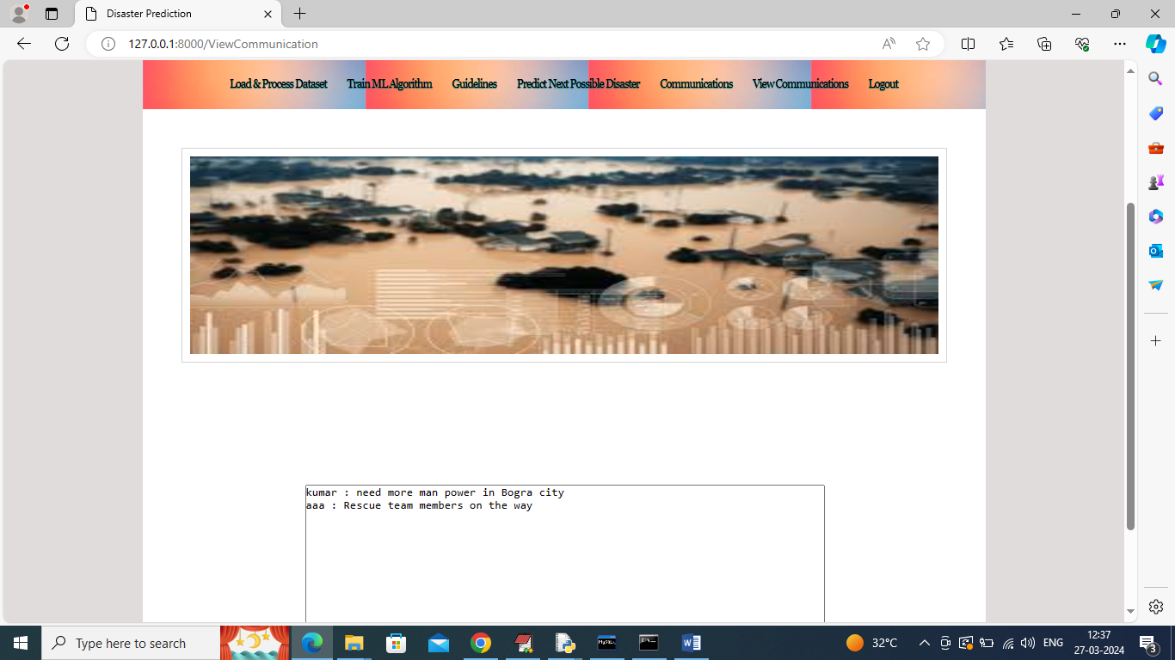

In above screen in view communication we can see all communications happening between different users

So by following above screens you can predict future disaster place and manage events before it occur